UK Year 8 – Pre-test
15 Questions | 60 minutes | Calculator allowed
1. Calculate $\frac{3}{8}$ of 27
Give your answer as a fraction.

______________________

2. Here are five calculations.
Circle the two calculations that give the same answer when rounded to 1 decimal place.

$56$$÷3$
$170 ÷ 9$
$113 ÷ 6$
$131 ÷7$
$93 ÷ 5$

3. Write the number 3.7452 correct to 2 decimal places.

_____________________
4. Look at the diagram.
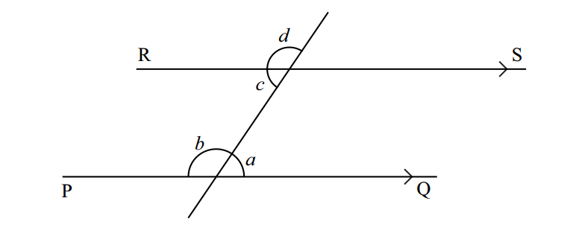
Lines PQ and RS are parallel.
Choose from these words to complete the sentences.
opposite alternate supplementary corresponding complementary
Angles $b$ and $d$ are ______________________
Angles $a$ and $c$ are ______________________

5. $44 is shared between David, Jo and Mary in the ratio 2 : 3 : 5
How much does each receive?

David $__________________________________

Jo $__________________________________

Mary $__________________________________

6. a) Pens cost 36 cents each.
Pencils cost 12 cents each.

i) Write an expression for the cost of $y$ pens.

__________________________________ cents

ii) Complete the formula for working out the total cost ($C$) of $y$pens and $z$ pencils.

__________________________________ cents

b) The formula for the total cost ($C$) of $q$ rulers and $s$ erasers is $C=40q+15s$
Work out the total cost of 7 rulers and 4 erasers.

__________________________________ cents

7. A new car costs $14 000
Every year it loses 18% of its value.
How much is the car worth after 2 years?

$__________________________________
8. Aaron and Bobby are brothers.
They go to the same school.
Aaron leaves home at 8:00 am and walks to school.
Bobby leaves home at 8:15 am and cycles to school.
Bobby arrives at 8:30 am.
The graph shows their journeys.
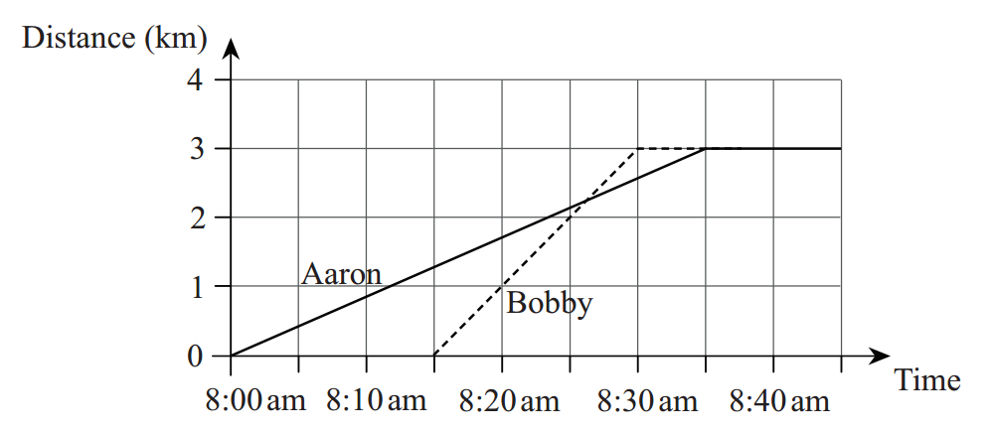

- At what time did Aaron arrive at school?

_______________________________
- How far is the school from the brothers’ home?

_____________________________km
- At what time does Bobby pass Aaron?

_______________________________

9. a) Complete the table of values for $y=2x-3$
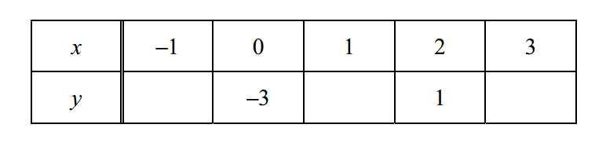
b) Plot the points on the grid and draw the line$y=2x-3$
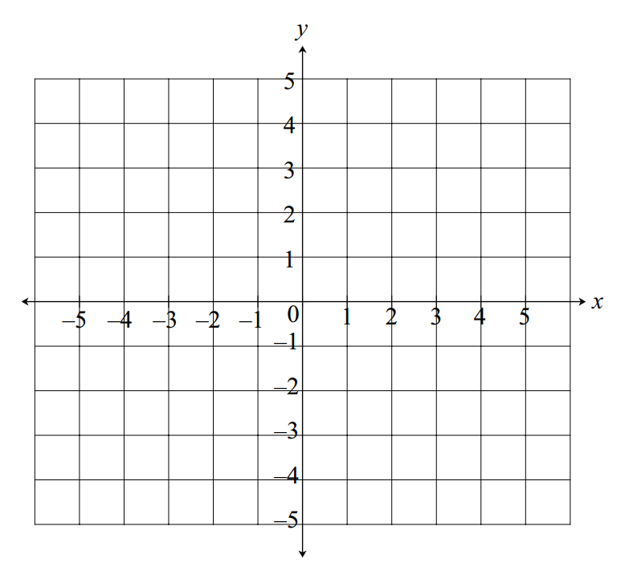
c) Is the point with coordinates (15, 29) on the line $y=2x-3$?
Explain your answer.
Yes/No because
____________________________________________________________________________
____________________________________________________________________________

10. A mapping multiplies the input by 4 and then subtracts 3
When the input is $x$ the output is $y$.
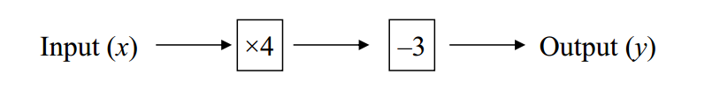

- Write an expression for $y$ using $x$.

$y=$ _________________________________

b) Write a value of $x$ when $y=31$.

$x=$ _________________________________

11. A biased dice is thrown.
The probability that it will land on a 6 is 0.8
What is the probability that it will not land on a 6?

_________________________________
13. Some students were asked to choose their favourite colour from red, blue, green and yellow.
The bar chart and pie chart show the results.
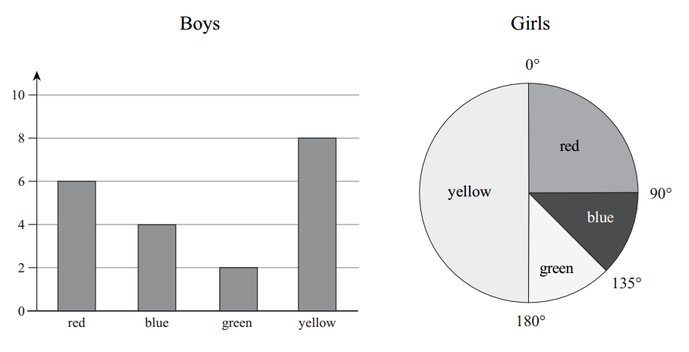
The same number of both boys and girls chose green.
How many girls were asked altogether?

_________________________________ girls

14. Write terms in the boxes so that the statements are correct.
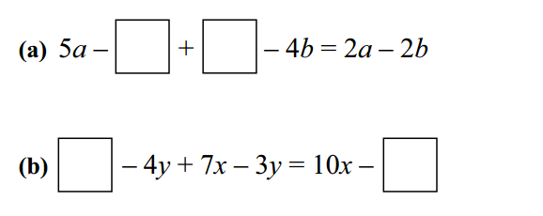

15. Look at these shapes.
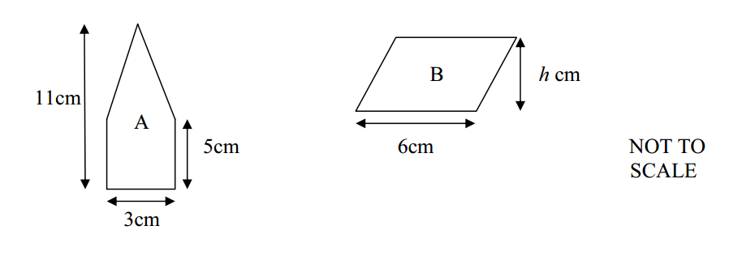
a) Work out the area of shape A.

_________________________________ $cm^{2 }$

b) Parallelogram B has the same area as shape A.
Work out the height h of parallelogram B.

_________________________________ $cm$

